Luke Jakoywa is a servant-hearted leader, movement-builder, and generational visionary. As the Presiding Bishop of Outreach Community Church, he oversees more than 30 branches across Kenya and beyond. He is the founder of Sheepcare Community Centre, a sanctuary of hope serving over 700 children daily through education, feeding, and spiritual empowerment.
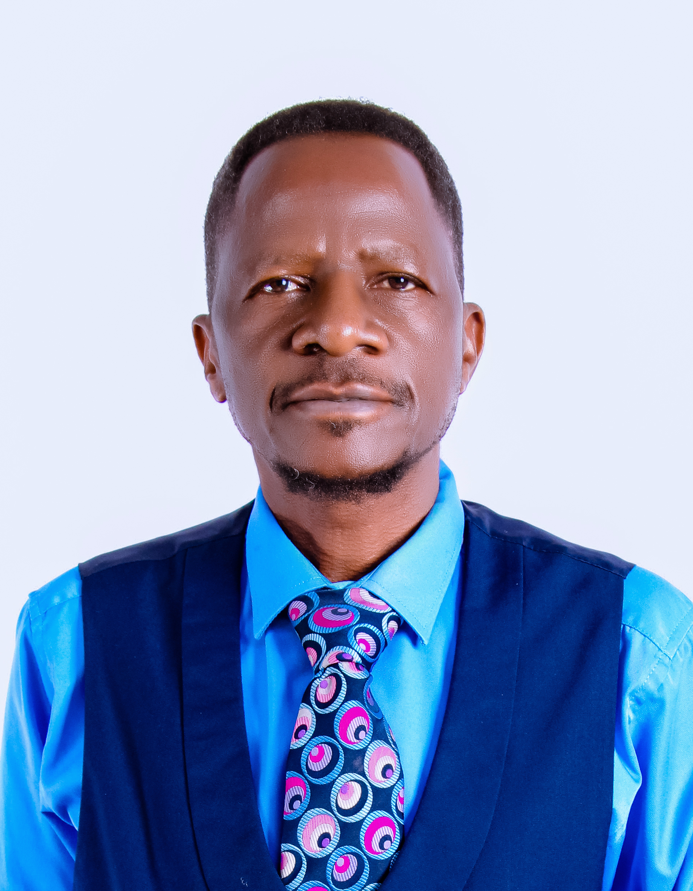
Luke’s leadership journey is marked by rare humility—having served faithfully under Bishop Dan Ogutu for 24 years before receiving the mantle through a Spirit-led, peaceful succession. His story is now a continental model for courageous transition and legacy multiplication.
A gifted curriculum architect, Luke designs transformational devotion manuals, ceremonial commissioning experiences, and symbolic rituals that empower children and leaders to walk in purpose. His work weaves together narrative pedagogy, trauma-informed healing, and faith-rooted innovation.
He is the visionary behind Operation KONY—a movement that he founded to deal with poverty in his rural community. His writing, mentorship, and ministry are driven by one sacred conviction: that every child can be a world changer, and every leader must learn to let go.
Luke holds Bachelor in Computer Science, Bachelor in Bible Theology, and Master Degree Communication Development, and is a certified mediator for Kenya’s Judiciary. A recipient of the Presidential Golden Award for excellence, he left a successful corporate career to serve the broken, the orphaned, and the hungry.
Luke lives between Nairobi’s urban pulse and Kisumu’s rural soul, always in service, always in legacy.

